**Médias das diferenças de logs de preços entre ABCfarma e IMS no período de Jan/2011 a Mar/2015-Brasil**

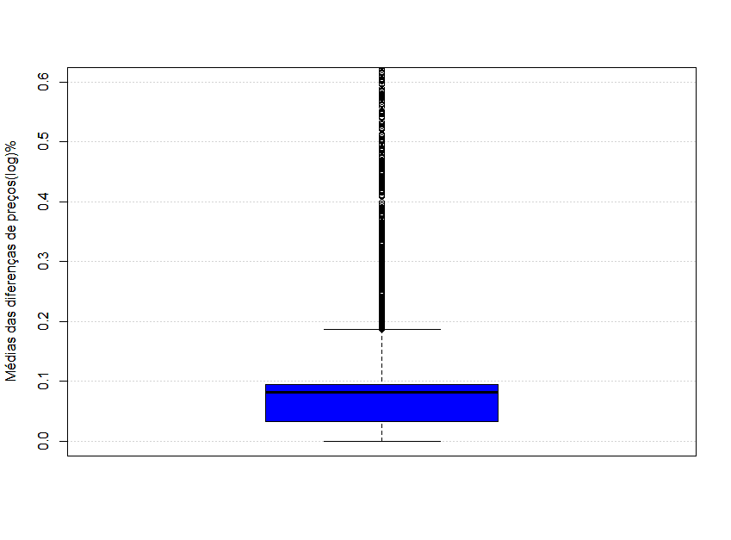

|  |  |  |  |  |  |  |  |  |  |
| --- | --- | --- | --- | --- | --- | --- | --- | --- | --- |
| Min. | 25% | 50% | 75% | 90% | 95% | 99% | Max. | Mean | NA's |
| 0 | 0,033 | 0,081 | 0,095 | 0,562 | 5,068 | 506,523 | 3580 | 14,47 | 2257 |

**Desvios padrões das diferenças de preços entre ABCfarma e IMS no período de Jan/2011 a Mar/2015-Brasil**

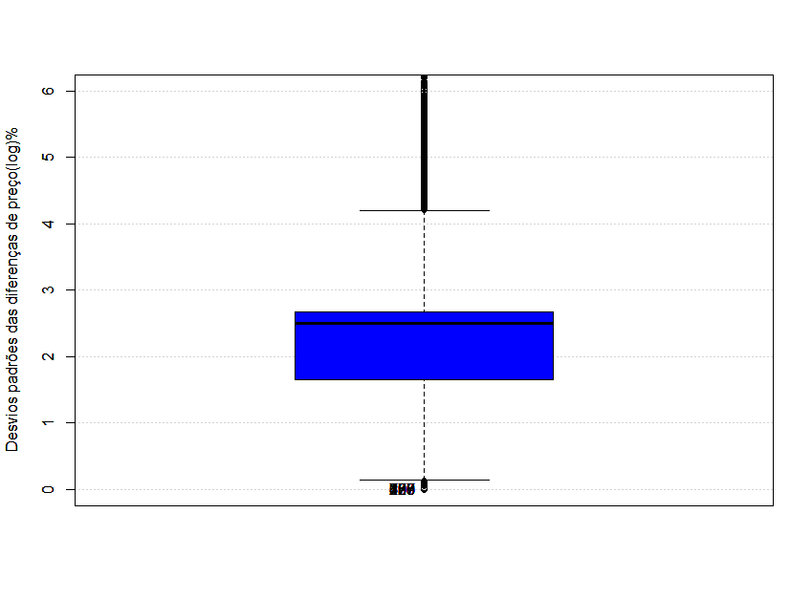

|  |  |  |  |  |  |  |  |  |  |
| --- | --- | --- | --- | --- | --- | --- | --- | --- | --- |
| Min. | 25% | 50% | 75% | 90% | 95% | 99% | Max. | Mean | NA's |
| 0 | 1,661 | 2,502 | 2,680 | 5,911 | 13,343 | 55,830 | 382,6 | 4,534 | 2257 |

**Medianas das diferenças de logs de preços entre ABCfarma e IMS no período de Jan/2011 a Mar/2015-Brasil**

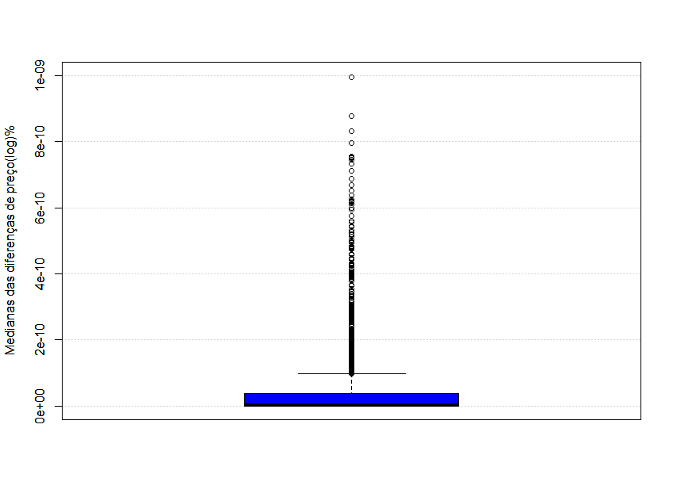

|  |  |  |  |  |  |  |  |  |  |
| --- | --- | --- | --- | --- | --- | --- | --- | --- | --- |
| Min. | 25% | 50% | 75% | 90% | 95% | 99% | Max. | Mean | NA's |
| 0 | 0,000 | 0,000 | 0,000 | 0,000 | 1,011 | 509,309 | 3541 | 14,31 | 2257 |

**Desvio absoluto mediano das diferenças de preços entre ABCfarma e IMS no período de Jan/2011 a Mar/2015-Brasil**

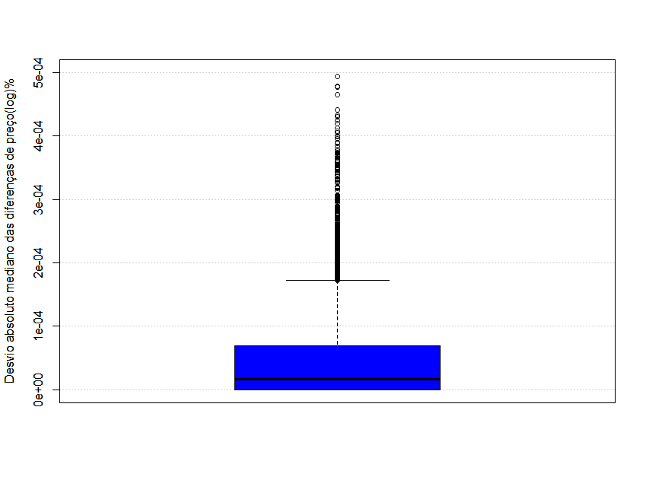

|  |  |  |  |  |  |  |  |  |  |
| --- | --- | --- | --- | --- | --- | --- | --- | --- | --- |
| Min. | 25% | 50% | 75% | 90% | 95% | 99% | Max. | Mean | NA's |
| 0,0000 | 0,0000 | 0,0000 | 0,0001 | 0,0002 | 0,0087 | 5,1563 | 401,1 | 0,3338 | 193 |

**Mínimos das diferenças de preços entre ABCfarma e IMS no período de Jan/2011 a Mar/2015-Brasil**

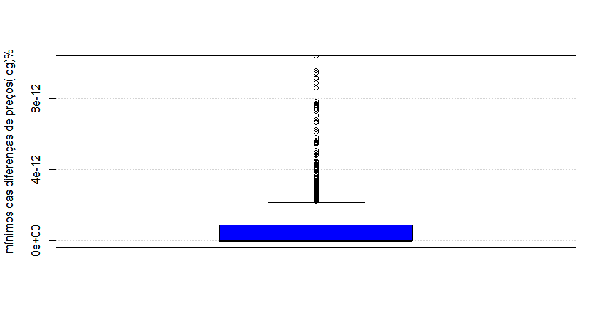

|  |  |  |  |  |  |  |  |  |  |
| --- | --- | --- | --- | --- | --- | --- | --- | --- | --- |
| Min. | 25% | 50% | 75% | 90% | 95% | 99% | Max. | Mean | NA's |
| 0,0000 | 0,0000 | 0,0000 | 0,0000 | Inf | Inf | Inf | Inf | Inf | - |